Coffee 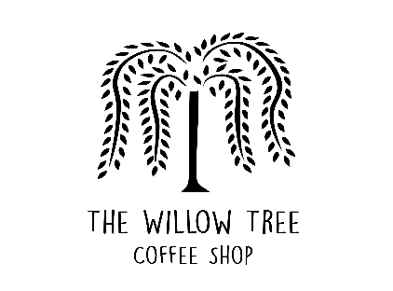
Cappuccino - £2.85
Latte - £2.85
Flat White - £2.90
Americano – £2.85
Mocha - £2.85
Filter Coffee - £2.55
Espresso - £1.75
Extra Shot - £1.20

HOT DRINKS
Hot Chocolate - £2.85
Luxury Hot Chocolate - £3.00
Chai Latte - £2.80
Babyccino - £1.35

TEAS
Pot of Tea - £2.35
Decaf Tea – £2.35
HERBAL TEAS
Camomile - £2.65
Earl Grey - £2.65
Mint Tea - £2.65
Rosehip Tea - £2.65
Green Tea - £2.65
English Breakfast -£2.65

COLD DRINKS
Juice Carton - £1.40
Coke/ Diet Coke - £1.55
San Pelligrino - £1.80
Ribena - £1.70
Still Water - £1.45
Sparkling Water - £1.45

